**Project Design Phase-II**

|  |  |
| --- | --- |
| **Date** | **24 June 2025** |
| **Team ID** | **LTVIP2025TMID24654** |
| **Project Name** | **Shopez : one-stop shop for online purchases** |
| **Mentor Name** | **Dr Shaik Salma Begam** |
| **Maximum Marks** | **4 Marks** |

**Data Flow Diagram & User Stories**

**Data Flow Diagram (DFD)**

A Data Flow Diagram (DFD) visually represents how information flows within Shopez. It shows how data enters and leaves the system, what changes the information, and where data is stored.

**Example: Shopez DFD Level 0**

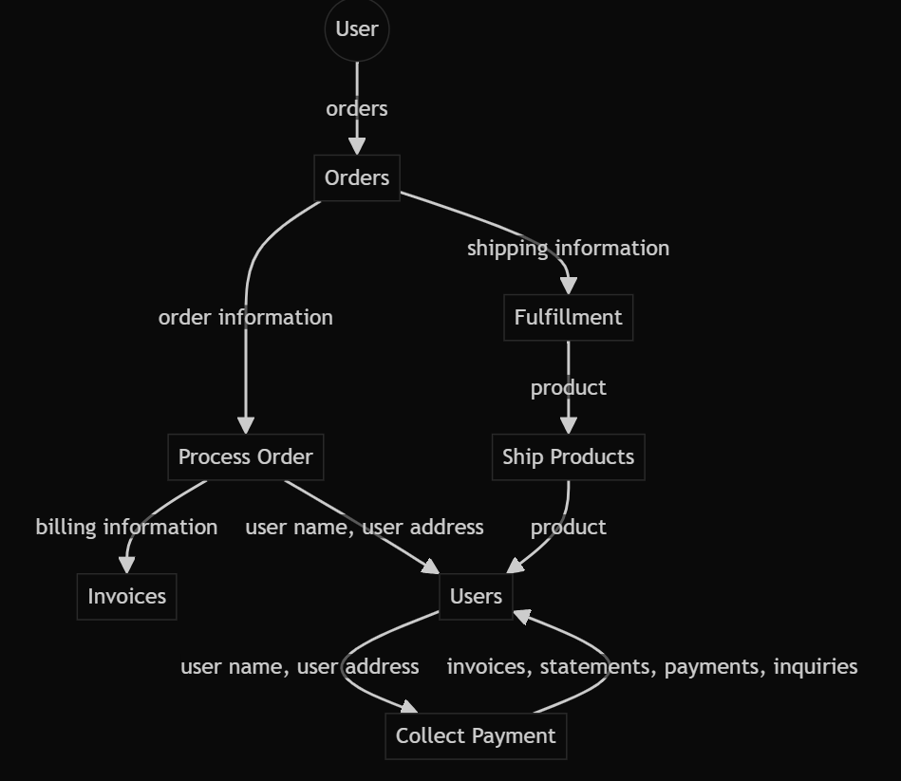

**Description:**

* Users place orders, which are processed and stored.
* Order processing generates invoices and collects payment.
* Shipping and fulfillment are managed, and users can track their orders.

|  |  |  |  |  |  |  |
| --- | --- | --- | --- | --- | --- | --- |
| User Type | Functional  Requirement (Epic) | User Story Number | User Story / Task | Acceptance Criteria | Priority | Release |
| Customer (Mobile/Web) | Registration | USN-1 | As a user, I can register for the application by entering my email, password, and confirming my password. | I can access my account / dashboard | High | Sprint-1 |
| Customer (Mobile/Web) | Registration Confirmation | USN-2 | As a user, I will receive a confirmation email once I have registered for the application. | I can receive confirmation email & click confirm | High | Sprint-1 |
| Customer (Mobile/Web) | Login | USN-3 | As a user, I can log into the application by entering email & password. | I can log in and access my dashboard | High | Sprint-1 |
| Customer (Mobile/Web) | Product Browsing & Search | USN-4 | As a user, I can browse products by category and search for products. | I can see products by category and search results | High | Sprint-1 |
| Customer (Mobile/Web) | Cart & Order Placement | USN-5 | As a user, I can add/remove products to/from my cart and place an order. | I  can manage my cart and place an order | High | Sprint-2 |
| Administrator | Admin Management | USN-6 | As an admin, I can add/edit/delete products, manage users, and view all orders. |  |  |  |

**User Stories**